Kathy Fisher
Indiana University – Bloomington
Kelley School of Business
kathfish@indiana.edu

UNDERSTANDING YOURSELF HELPS YOU UNDERSTAND YOUR AUDIENCE ASSIGNMENT DETAILS
Warm-up Assignment Prior to Class:
Read To Get Better at Understanding Other People, Start with Yourself and reflect upon your own self-awareness.
In Class Activity:
Personal Identity Wheel Exercise
- Individual time (5 minutes) – Ask students to quietly fill out their Personal Identity Wheel (page 2)
- Partner sharing (3-5 minutes) – Time to pair with a teammate and introduce yourself by sharing your wheel.
- Group exchange (5 minutes) – Pass out stickers and ask student to find space on the wall with their teams to put their wheels side by side. Walk from page to page and put your initials next to something you have in common with the person’s page you are reading (you didn’t have to write the same thing in the category. Ex: You wrote pizza is your favorite food but you LOVE Thai food and that’s what your teammate wrote, still initial it.)
- Debrief (5 minutes)
  - Was this chart hard to fill out?
  - What question posed the biggest challenge?
  - What are a few things you learn that your group has in common?
  - Would you know these things about your teammates without asking the right questions?
  - Once you knew these simple things, did it make it easier to connect with your teammates?
Out of Class Activity & Presentation:
Complete the Social Identity Wheel (page 3). Students will not have to turn this in as it is a very personal exercise but will help begin to shape how they perceive themselves and how others perceive them which will assist them in preparing for the presentation. Students are asked to deliver the “Organization Presentation” to demonstrate their understanding of organizational structure while using audience analysis and sharing what three traits/identities they believe most make them who they are. While presenting they are asked to give feedback with an “Active Listening” form (page 4).
Presentation Description and Rubric

Personal Identity Wheel

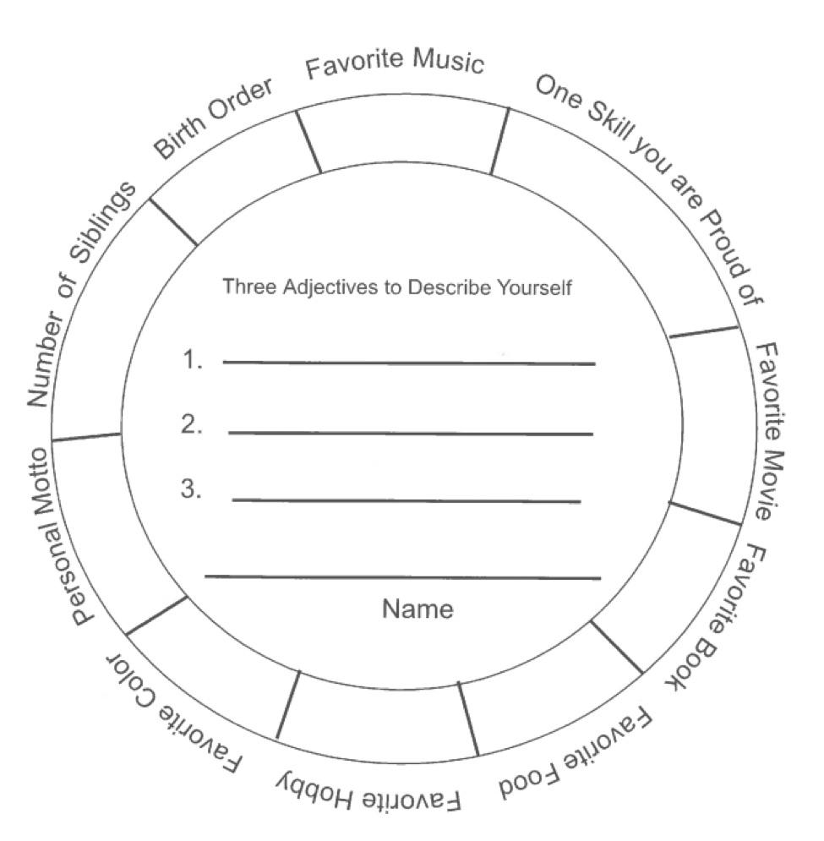

Resource hosted by LSA Inclusive Teaching Initiative, University of Michigan (http://sites.lsa.umich.edu/inclusive-teaching/)
Social Identity Wheel

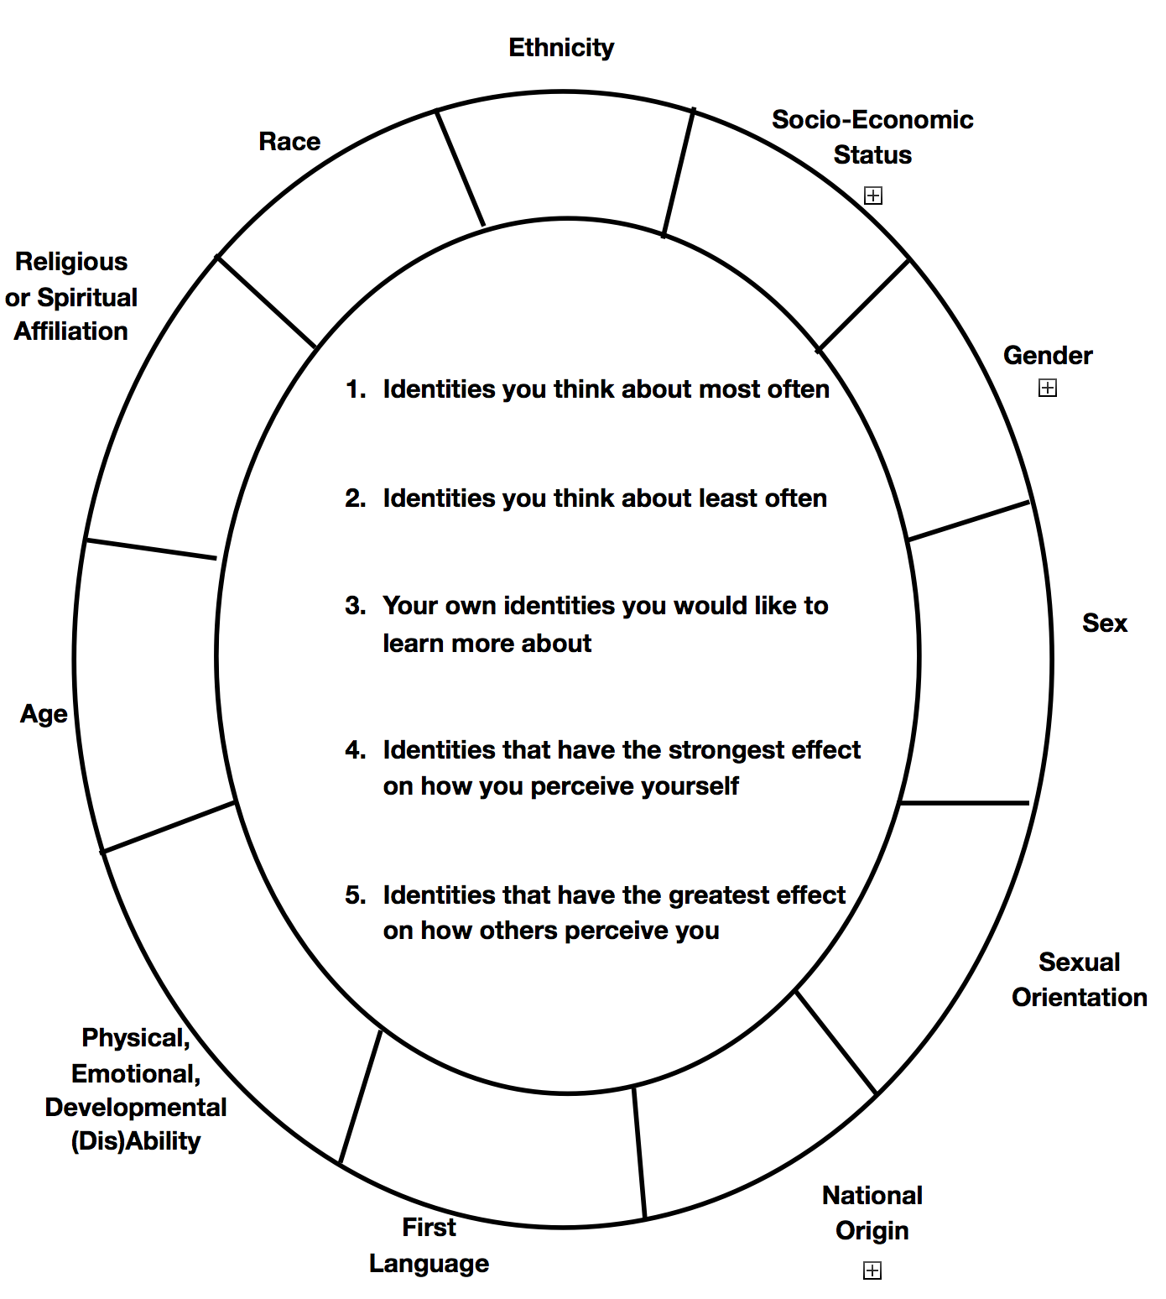

Resource hosted by LSA Inclusive Teaching Initiative, University of Michigan (http://sites.lsa.umich.edu/inclusive-teaching/).

Name:_______________________________
ACTIVE LISTENING – ORGANIZATION PRESENTATION
Name something you learned about someone that surprised you or that you didn’t know:

An example of a good hook (and name of presenter if you know it):
An example of a creative transition (and name of presenter if you know it):
An example of a well organized closing (and name of presenter if you know it):
__________________________________________________________________________________________

